|  |
| --- |
| **PT. BERLIAN SISTEM INFORMASI** |
| **Operating Lease – System Setting** |
| **USER MANUAL GUIDE** |
|  |
| **VERSION 1.0** |
| **5/28/2016** |

|  |
| --- |
| All material contained in this manual including text, graphics, icons and images contain proprietary and confidential information of PT. Berlian Sistem Informasi and are protected by international intellectual property and other laws. The compilation of all text, graphics, icons and images in this Manual is the exclusive property of PT. Berlian Sistem Informasi. No modification, rental, lease, sale, transmission, distribution, reposting or creation or derivate works based on the material in this Manual is allowed, unless with the express permission of PT. Berlian Sistem Informasi. |

# REVISION HISTORY

|  |  |  |  |
| --- | --- | --- | --- |
| Date | Revision | Description | Author |
| 4/7/2016 | 0.1 | Initial Document | Sabilla Pravita Larassati |
| 5/28/2016 | 1.0 | 1st Baseline | Grand Zah Putra |

# TABLE OF CONTENT

**REVISION HISTORY 2**

**TABLE OF CONTENT 3**

**SYSTEM SETTING 4**

**APPROVAL PATH SETTING 4**

**1.1 List of Approval Path 4**

**1.2 Create Approval Path 6**

**1.3 Edit Approval Path 12**

**1.4 List of Escalation Approval Path 15**

**1.5 Approval for Escalation Approval Path 16**

# SYSTEM SETTING

Operating Lease Support System – System setting modules is consisting of **Approval Path Setting** and **Format Number setting**. With this module, user can configure approval path for each approval features in some modules. While format number setting is configured in background and cannot be set by user.

# APPROVAL PATH SETTING

Approval Path Setting is a configuration setting for approval flow. Using this feature, user can set the PIC and role for each module. The module will display list of approval path, create approval path, edit approval path, and manage manual escalation. Approval Path Setting will be used by DSF authorized user to set approval path for the following module:

* SKD approval
* Agreement approval
* Purchase order approval
* Replacement unit approval
* Manage work order
* Billing creation
* Manage warning letter
* Manage return authorization letter

## List of Approval Path

List of Approval Path will display approval list that already created. To access the list of approval path, please hover to menu System Setting, and click on Approval Path Setting menu.

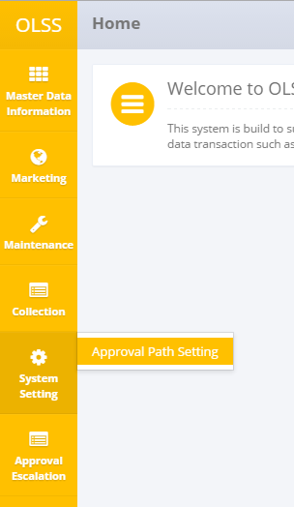

Screen 1: Home screen – System Setting

System will display data on List of Approval Path screen.

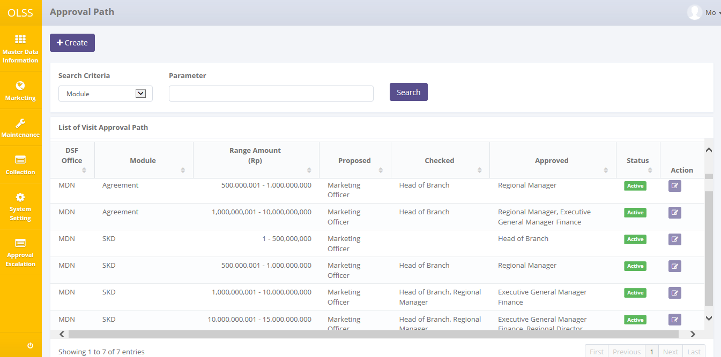

Screen 2: Approval path screen

In this screen, user can view approval path list with information such as the DSF Office, module, range amount, list of role which is allowed to propose, check, approve, and approval path status which is divided into two statuses:

* Active: approval path setting is active and used in approval flow for specific module.
* Inactive: approval path setting hasn’t applied for specific module.

On Approval Path screen, there are two buttons showed:

* Create: create new approval path.
* Edit: edit existing approval path.

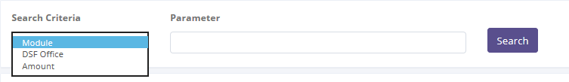

Screen 3: Approval Path Search Criteria

User abled to search specific criteria such as document based on DSF office, module, or amount. After choosing criteria, input value in parameter field and click Search button to show search result.

## Create Approval Path

To create new approval path, navigate to Approval Path screen and click Create button on top of the screen.



Screen 4: approval path list screen

System will display Create Approval Path screen:

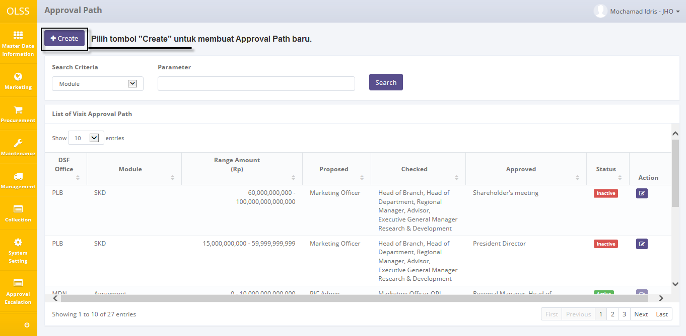

Screen 5: create approval path screen

User can start creating the approval path by inputting data on the fields shown. Below is the description for each field:

1. Approval path information:

* Module: fields will consist of OLSS module that have approval feature. Select which module the approval path will be created.

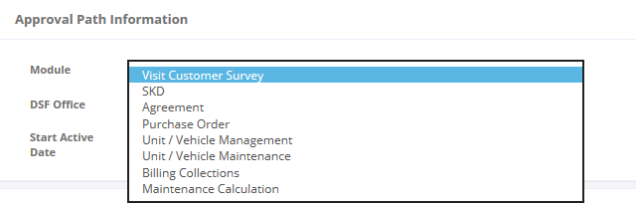

Screen 6: approval path module list

* DSF Office: fields will show pop up screen that consist of DSF office list. Select which office the approval path will be set into.

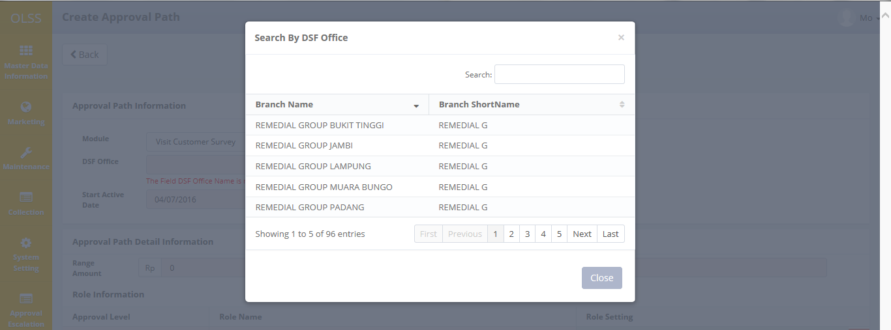

Screen 7: approval path DSF office list

* Start Active Date: pick the active date. Selecting the current date will automatically set the approval path as Active after saving the data.

1. Approval path detail information:

* Range amount: input specific range amount.
* Role information:

There are 3 fields that need to be selected:



Screen 8: Approval Level

* Approval level: select approval activity, which is Proposed, Check, Approve, or Reject. Please note that approval level will only show **Proposed** when inputting first role information input.
* Role Name: select authorized role to do the approval. Role name list is shown below:

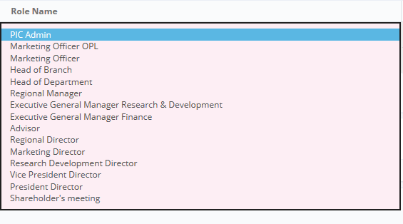

Screen 9: approval path role name list

* Role Setting: select **must sign** if the authorized user has to sign the document and he/she couldn’t be escalated, and select **not must sign** for the opposite. Only active if the approval level is **Approve**.

After all the fields have been inputted, click  button to add more role information for another approval level. One approval path should have at least a role for propose, and a role for approve, below is the example for one approval path.

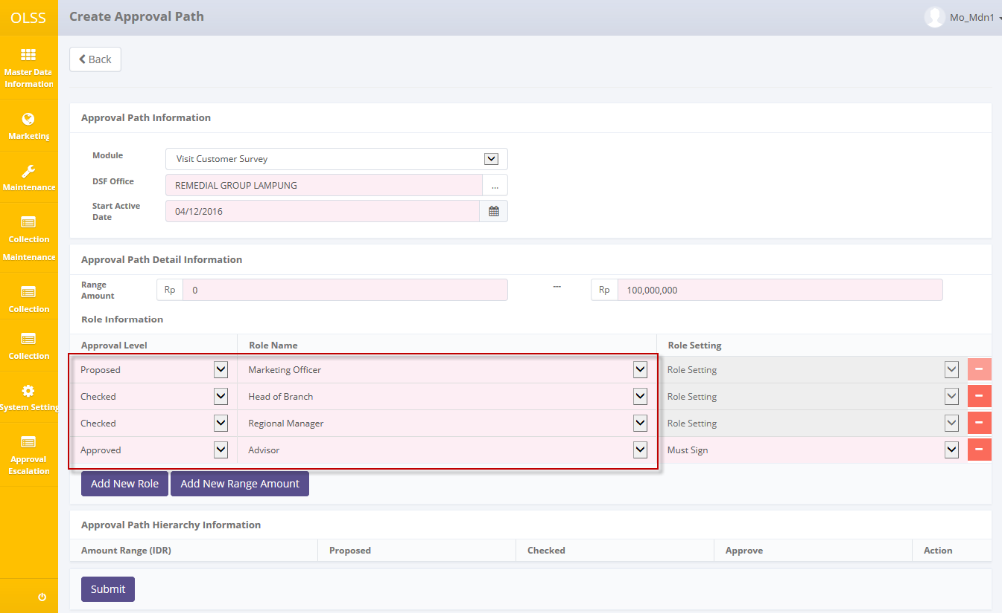

Screen 10

To lock the created approval path into approval path hierarchy information table, user should click  button. Data that has been inputted will be saved temporarily on the bottom of the screen.

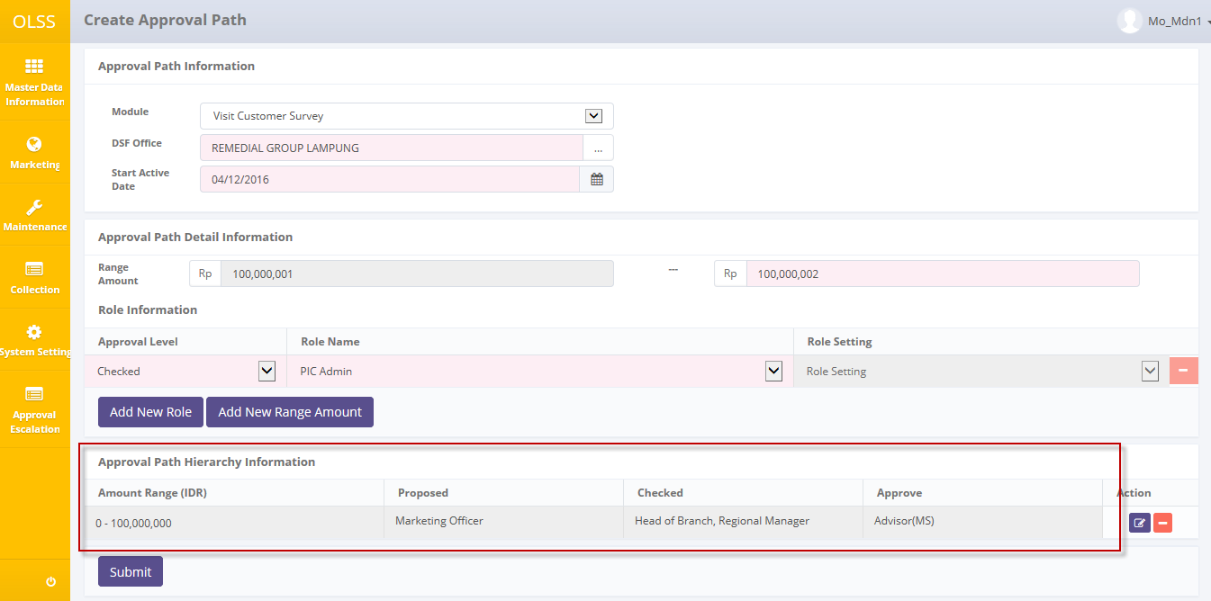

Then user can input more approval path under the same module and branch, and the range amount will automatically set for the maximum amount range added with Rp.1,- from previous approval path. For the second approval path, user couldn’t have to input **Propose** role because the Propose role will be same with the previous approval path.

Click submit button on the bottom of the fields to save the approval path. But before submitting the data, please note that:

1. One role job (job title) could only have one authorization (proposed, checked, or approved) on the approval path. Example: if MO has been set as Propose, then MO can’t be set as any role anymore.
2. Role setting column only active when the approval level is **Approve**.
3. User can input same amount range for an approval path that has different propose’s role (job title) for the same module and branch.
4. User can’t input same amount range for an approval path setting that has same propose’s role (job title) for the same module and branch
5. Some fields are mandatory, submitting data while leaving the fields blank or wrong will display error message under the specific fields. Below is the example for error message:

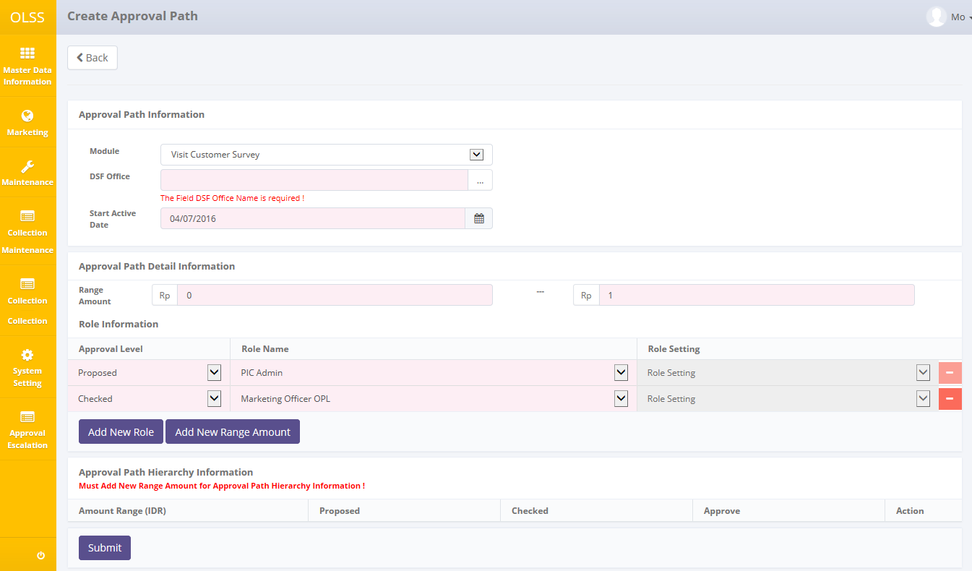

Screen 11: approval path error message after submit

After clicking submit, confirmation pop-up dialog will show up. Click Yes to continue.

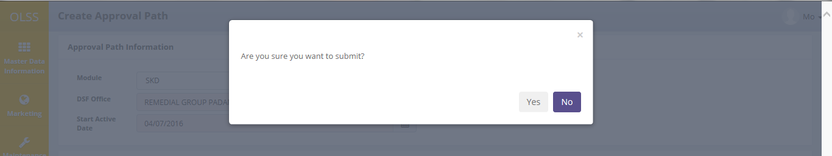

Screen 12: approval path confirmation pop up

System will automatically go back to list of Approval Path, and display success or failed notification on top of the screen.



Screen 13: approval path success notification

Approval path data can’t be edited and deleted once **active**. Therefore user has to create a new approval path that has the same **module**, **DSF branch**, and **Propose’s Job Title.** By creating a new approval path with same criteria, the new one will be set as active, and the previous will change to inactive. For example: the last approval path is Proposed by Ms. Herni, for module SKD and Medan Branch. Then, to make the approval path inactive, user have to create the same criteria for the new approval path, by setting the Propose’s job title as Ms. Herni, for module SKD, and Medan Branch.

## Edit Approval Path

Edit button is enabled if the approval status is **inactive.** To edit approval path, user have to find inactive approval path. First sort the status column to easily find the inactive approval path. Then click edit button on selected data.

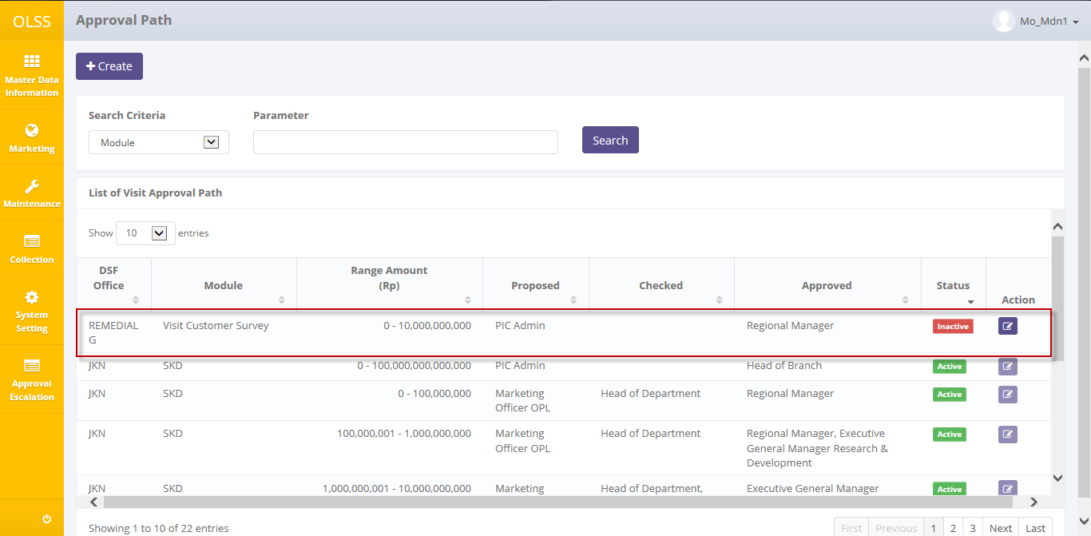

Screen 14: approval path screen – edit approval path

System will display Edit Approval Path screen.

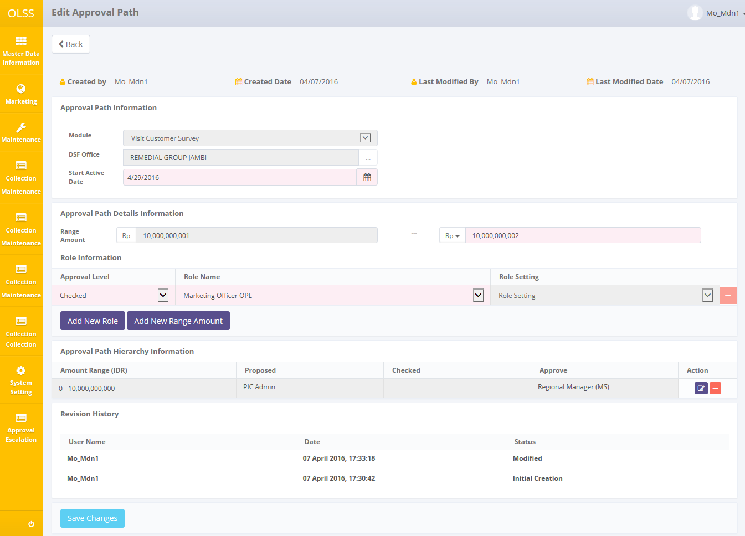

Screen 15: edit approval path screen

There is a Revision History field on the bottom of the screen, consist of the user information that had make changes to the records. Fields that can be modified is mostly the same with approval path creation fields. But some fields such as module, DSF office, and lowest range amount can’t be changed. Therefore if user planned to edit the fields, user have to create new approval data.

If data already changed on the screen, user can save a data on the system by clicking **Save Changes** button. There are mandatory fields marked with red background field that should be inputted and it can’t leave as blanks. If you leave them blanks, system will notified it after you clicking **Save Changes** button. After Save Changes is clicked, confirmation pop up will show. Click **Yes** to continue.

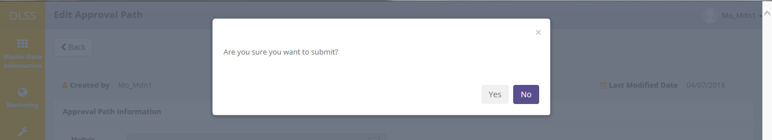

Screen 16: Edit approval path confirmation pop up

System will automatically navigate back to Approval Path screen. System will notified success or failed notification on top of the screen.



Screen 17: edit approval path success notification

## Manual Escalation

OLSS give feature for manual escalation in case the approval path can’t progress accordingly. For example, the approval flow is from MO(propose) – HOB(check) – RM(check) – ADV(approve). If HOB can’t check the document, then MO can use this feature to escalate the approval to RM. Then the next approval will change to RM.

To start approval escalation, access menu OLSS and click on approval escalation menu.

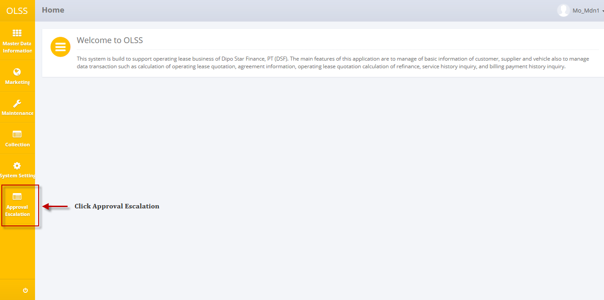

Screen 18: Home screen – Approval Escalation

System will display List of Document’s Approval Path Escalation as shown below:

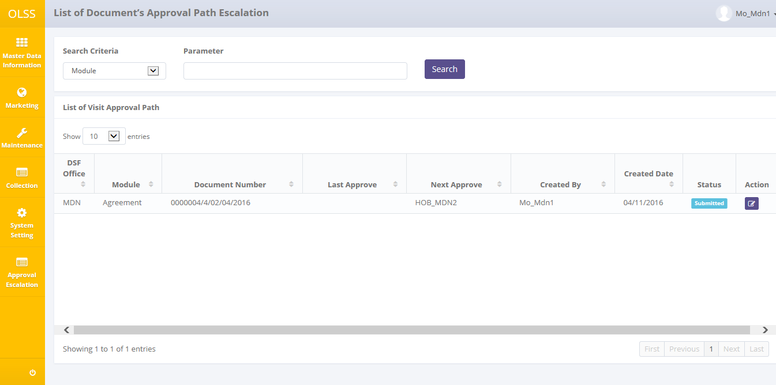

Screen 19: List of document’s approval path escalation screen

List of document’s approval path escalation will show document numbers that already checked or approved by authorized user. In the screen, there is showed the module, document number, last – next approve, created by, created by, and document status.

Search document which needs escalation at list of document approval path. Click edit button and system will display document’s approval path escalation detail screen for selected document.

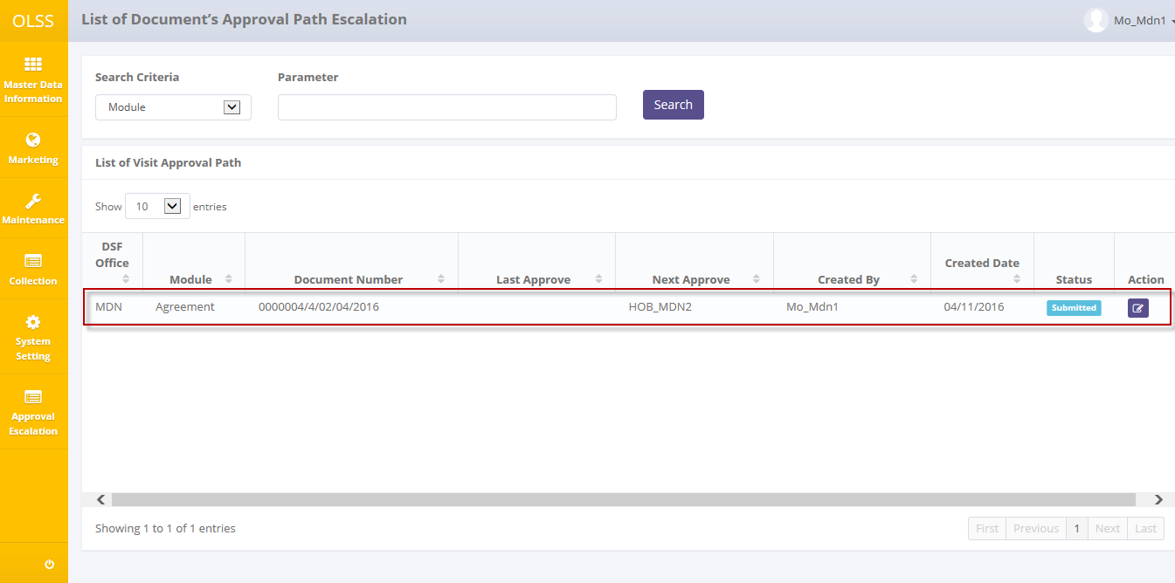

Screen 20: List of document’s approval path escalation – escalate document

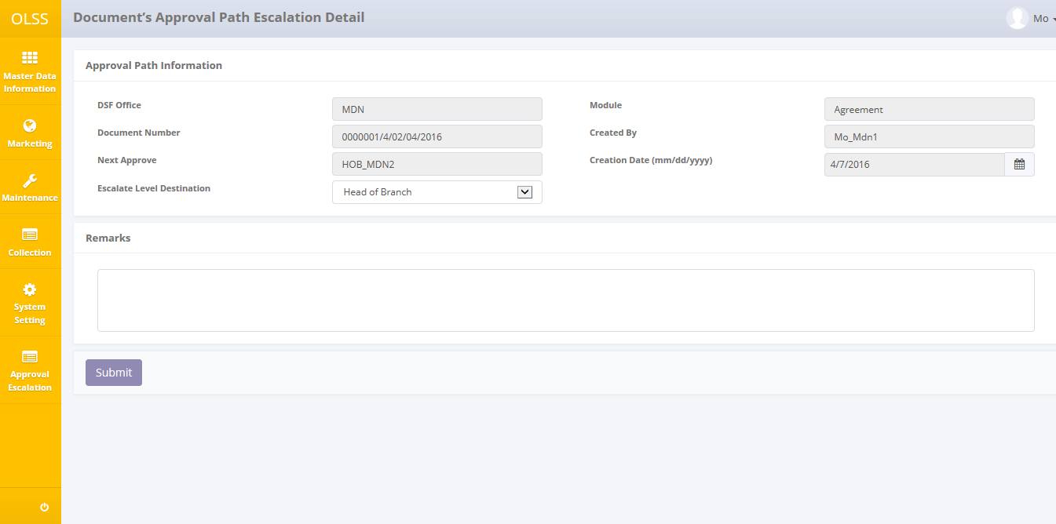

Screen 21: Document’s approval path escalation detail screen

User should fill the mandatory fields as follow:

1. Escalate level destination: Select which level the approval will be escalated. The selected **Job Title** is the one who will continue the approval process. For example, the approval path is: HOB checked the document, and then escalates the document to ADV. So, the one who will continue the approval process is ADV.
2. Remarks: input escalation reason, for example: RM is on sick leave therefore the document can’t be checked by RM in due time.

While escalating the approval, please note that:

1. If the last approve is **Propose** level, the maximum level to be escalated is the highest **Check** level. For example: if there are 3 role who check: HOB (check) – RM (check)-ADV (check), then MO (propose) able to escalate the document to the highest checker which is ADV.
2. If the next approve is **Approve** level, system will check if the role has ‘must sign’ (MS) code or ‘Not Must Sign’ (NMS) code. If the code is MS, the manual escalation can’t be executed, and warning message will be displayed. Role that has MS code have to sign the document, therefore the document can’t be escalated.

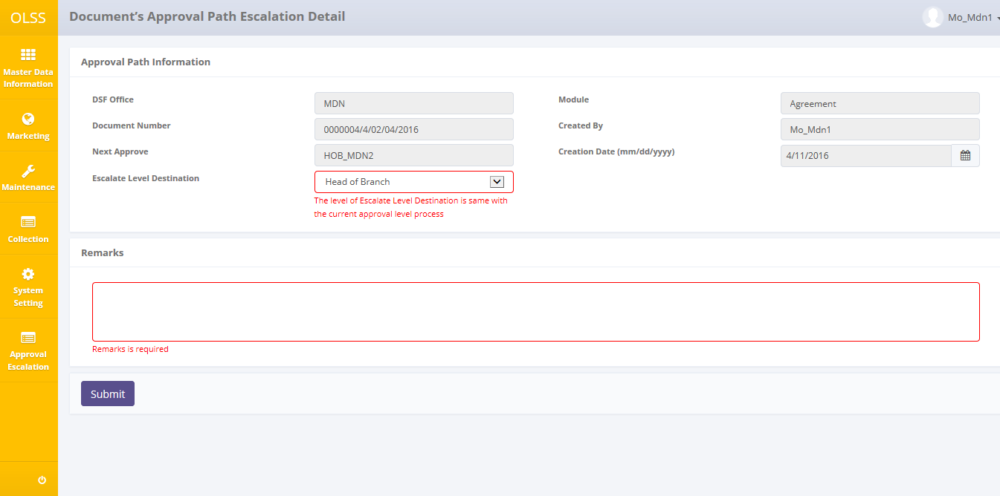

Screen 22: Document’s approval path escalation detail error message

Click submit button to escalate the document. Confirmation pop up dialog will show up, click Yes to continue.

Then system will automatically back to List of Document’s Approval Path screen, and system will notify success or failed notification on top of the document. Escalated document will change document status into **Escalated**.